If two or more computers are connected in a network, then they are sure to exchange information. Think of information as transport vehicles from one computer to another. So these transport vehicles would definitely need a path through which they can travel to reach their destination. And they also need to make sure that the path they take is the best possible path. To determine the path which the information would take Switching Techniques are used.

**Definition:** Switching technique is used to connect the systems for making one-to-one communication and decide the best route for data transmission.

There are mainly two types of switching:

1. **Circuit Switching:** A circuit-switched network is one of the simplest data communication methods in which a dedicated path is established between the sending and receiving device. In this physical links connect via a set of switches.

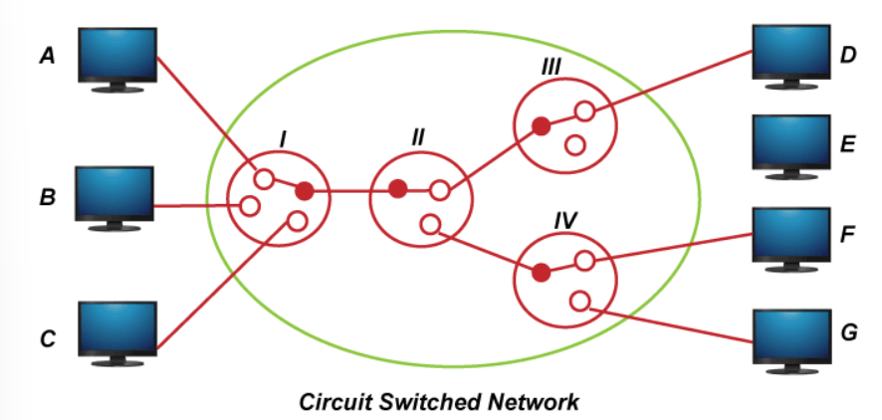

1. **Packet Switching:** In the Packet switching Network, the message is divide into packets. Each packet contains a header which includes the source address, destination address, and control information.

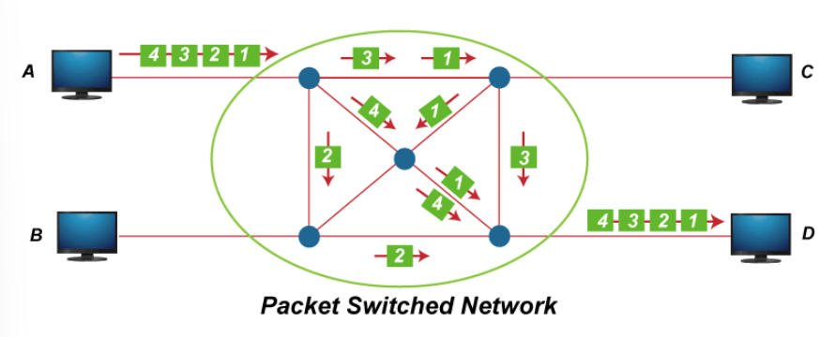

You will get to learn more about switching techniques and learn how these dedicated and non-dedicated routes work in higher classes.

**Data Communication Technologies:**

In the above part we learned how data is transferred from destination to source. Now we focus on through what, at what speed etc. of the data transmission.

Channel: Channels are nothing but mediums through which we exchange information in a network. Consider a network between two people when they speak to each other. The air molecules act as medium so that we can hear the other person’s voice. Similarly to get the information shared from a source to the destination, a medium must exist.

**Definition:** The path over which data is sent or received is called data channel. This data channel may be a tangible medium like copper wire cables or broadcast medium like radio waves. Transmission channel may be analog or digital.

Data Transfer Rate: The speed of data transferred or received over transmission channel, measured per unit time, is called data transfer rate. The smallest unit of measurement is bits per second (bps). 1 bps means 1 bit (0 or 1) of data is transferred in 1 second.

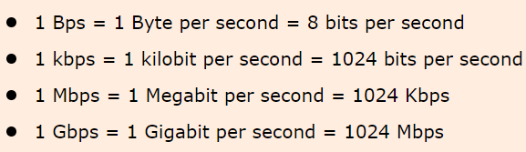

Bandwidth: Bandwidth in wireless communications is the maximum amount of data that can be transmitted over a given frequency band in a given amount of time. It is measured in Hertz (Hz), which is the unit of frequency.

Bandwidth is important in wireless communications because it determines the speed at which data can be transmitted. For example, a higher bandwidth allows for faster data transmission rates. This is important for applications such as streaming video and online gaming, which require a lot of data to be transmitted quickly.